DEU Computer Engineering
CME2002
Data Organization
&
Management

Lab 2 – XML Reading & Writing

Assoc. Prof. Dr. Adil ALPKOÇAK
Dr. Mete Uğur AKDOĞAN
Mansur Alp TOÇOĞLU
Mehmet Cengiz

Öeh
İsmail PARLAK
XML HANDLING
IntroductIon
In this lab session, you will primarily learn how to read and write XML files in C. We will be using libxml2 library for this purpose. First we will see how to set up this library so you can do it on your own computers as well.
lIbxml2

Step 1: Setup of libxml2

This library can be easily installed with the package manager. But for our Debian distributions we first need to update our package list with the following command:

sudo apt-get update

After updating the packet list, we can install the library with this command:

sudo apt-get install libxml2-dev

By default the library is setup under the following directory:

/usr/include/libxml2/libxml

Change directory to there and list the included files. Take the screen capture and paste it below.

Step 1:

XML in Practice

Step 2: Run the XML parse code.

Below is a code snippet that reads an XML file, parses it and prints an output. Note that the code tires to read from a XML file named note.xml that is under the same folder with the code. Copy that code to a file named parse.c, compile and run it. Inspect the output carefully. In order to compile a file, you have to include the following path:
-I/usr/include/libxml2 -lxml2.

Step 2:

#include <stdio.h>
#include <libxml/parser.h>
#include <libxml/tree.h>

static void print_element_names(xmlNode * a_node);

int main()
{
xmlDoc *doc = NULL;
xmlNode *root_element = NULL;
const char *Filename = "note.xml";

doc = xmlReadFile(Filename, NULL, 0);

if (doc == NULL)
{
printf("error: could not parse file %s\n", Filename);
}
else
{ /*
* Get the root element node
*/
root_element = xmlDocGetRootElement(doc);

print_element_names(root_element);
/*
* free the document
*/
xmlFreeDoc(doc);
}
/*
*Free the global variables that may
*have been allocated by the parser.
*/
xmlCleanupParser();

return (0);
}
/* Recursive function that prints the XML structure */

static void print_element_names(xmlNode * a_node)
{
xmlNode *cur_node = NULL;

for (cur_node = a_node; cur_node; cur_node = cur_node->next) {
if (cur_node->type == XML_ELEMENT_NODE) {
printf("Node Type: Element, name: %s \n Its children's type is: %d \n Its children's content is: %s \n", cur_node->name, cur_node->children->type, cur_node->children->content);
}
print_element_names(cur_node->children);
}
}

Below you can see the xmlNode structure and xmlElementTypes enumarations.
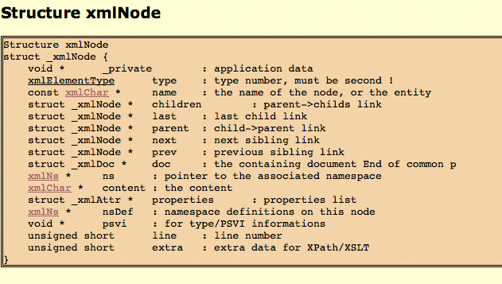
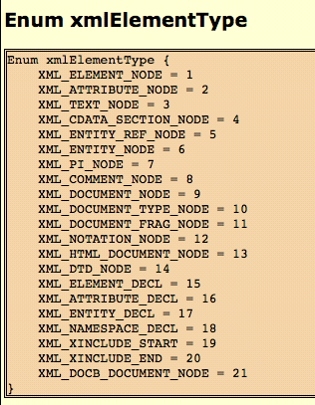
Step 3. Modify the xml file and parser code: Modify the xml file by adding another element with name date. Also add a date value to Jani's note. Following this, modify the parse.c file so that it only prints the date and the body of the message. The output should look like:
Date: 04/03/2014
Body: Don't forget me this weekend!

Paste your modified code below and upload your document.

Step3:

XML Writing

Step 1: Run the XML write code.

Below is a code snippet that creates an XML file. and writes it to a , parses it and prints an output. Copy that code to a file named write.c, compile and run it. Inspect the output carefully. Compile your code using the following path: -I/usr/include/libxml2 -lxml2.

#include <stdio.h>
#include <libxml/parser.h>
#include <libxml/tree.h>

int
main(int argc, char **argv)
{
xmlDocPtr doc = NULL; /* document pointer */
xmlNodePtr root_node = NULL, node = NULL, node1 = NULL;/* node pointers */
xmlDtdPtr dtd = NULL; /* DTD pointer */
char buff[256];
int i, j;

/*
* Creates a new document, a node and set it as a root node
*/
doc = xmlNewDoc(BAD_CAST "2.0");
root_node = xmlNewNode(NULL, BAD_CAST "root");
xmlDocSetRootElement(doc, root_node);

/*
* xmlNewChild() creates a new node, which is "attached" as child node
* of root_node node.
*/
xmlNewChild(root_node, NULL, BAD_CAST "node1",
BAD_CAST "content of node 1");
/*
* The same as above, but the new child node doesn't have a content
*/
xmlNewChild(root_node, NULL, BAD_CAST "node2", NULL);

/*
* xmlNewProp() creates attributes, which is "attached" to an node.
* It returns xmlAttrPtr, which isn't used here.
*/
node =
xmlNewChild(root_node, NULL, BAD_CAST "node3",
BAD_CAST "this node has attributes");
xmlNewProp(node, BAD_CAST "attribute", BAD_CAST "yes");
xmlNewProp(node, BAD_CAST "foo", BAD_CAST "bar");

/*
* Here goes another way to create nodes. xmlNewNode() and xmlNewText
* creates a node and a text node separately. They are "attached"
* by xmlAddChild()
*/
node = xmlNewNode(NULL, BAD_CAST "node4");
node1 = xmlNewText(BAD_CAST
"other way to create content (which is also a node)");
xmlAddChild(node, node1);
xmlAddChild(root_node, node);

/*
* A simple loop that "automates" nodes creation
*/
for (i = 5; i < 7; i++) {
sprintf(buff, "node%d", i);
node = xmlNewChild(root_node, NULL, BAD_CAST buff, NULL);
for (j = 1; j < 4; j++) {
sprintf(buff, "node%d%d", i, j);
node1 = xmlNewChild(node, NULL, BAD_CAST buff, NULL);
xmlNewProp(node1, BAD_CAST "odd", BAD_CAST((j % 2) ? "no" : "yes"));
}
}

/*
* Dumping document to stdio or file
*/
xmlSaveFormatFileEnc(argc > 1 ? argv[1] : "-", doc, "UTF-8", 1);

/*free the document */
xmlFreeDoc(doc);

/*
*Free the global variables that may
*have been allocated by the parser.
*/
xmlCleanupParser();

xmlMemoryDump();
return(0);
}

Macro: BAD_CAST

#define BAD_CAST
Macro to cast a string to an xmlChar * when one know its safe.

This is a basic byte in an UTF-8 encoded string. It's unsigned allowing to pinpoint case where char * are assigned to xmlChar * (possibly making serialization back impossible).
xmlNodePtr xmlNewChild (xmlNodePtr parent,
xmlNsPtr ns,
const xmlChar * name,
const xmlChar * content )

xmlAttrPtr xmlNewProp (xmlNodePtr node,
const xmlChar * name,
const xmlChar * value)
xmlNodePtr xmlNewText (const xmlChar * content)

xmlNodePtr xmlAddChild (xmlNodePtr parent,
xmlNodePtr cur)
xmlNodePtr xmlNewNode (xmlNsPtr ns,
const xmlChar * name)
xmlNodePtr xmlDocSetRootElement (xmlDocPtr doc,
xmlNodePtr root)
Step 2: Modify the XML writer.

Modify the XML writer code so that it can write the following XML document. Paste your code below.

<?xml version="1.0"?>
<catalog>
<book id="bk101">
<author>Gambardella, Matthew</author>
<title>XML Developer's Guide</title>
<genre>Computer</genre>
<price>44.95</price>
<publish_date>2000-10-01</publish_date>
<description>An in-depth look at creating applications
with XML.</description>
</book>
<book id="bk102">
<author>Ralls, Kim</author>
<title>Midnight Rain</title>
<genre>Fantasy</genre>
<price>5.95</price>
<publish_date>2000-12-16</publish_date>
<description>A former architect battles corporate zombies,
an evil sorceress, and her own childhood to become queen
of the world.</description>
</book>
</catalog>

Your Code:

